
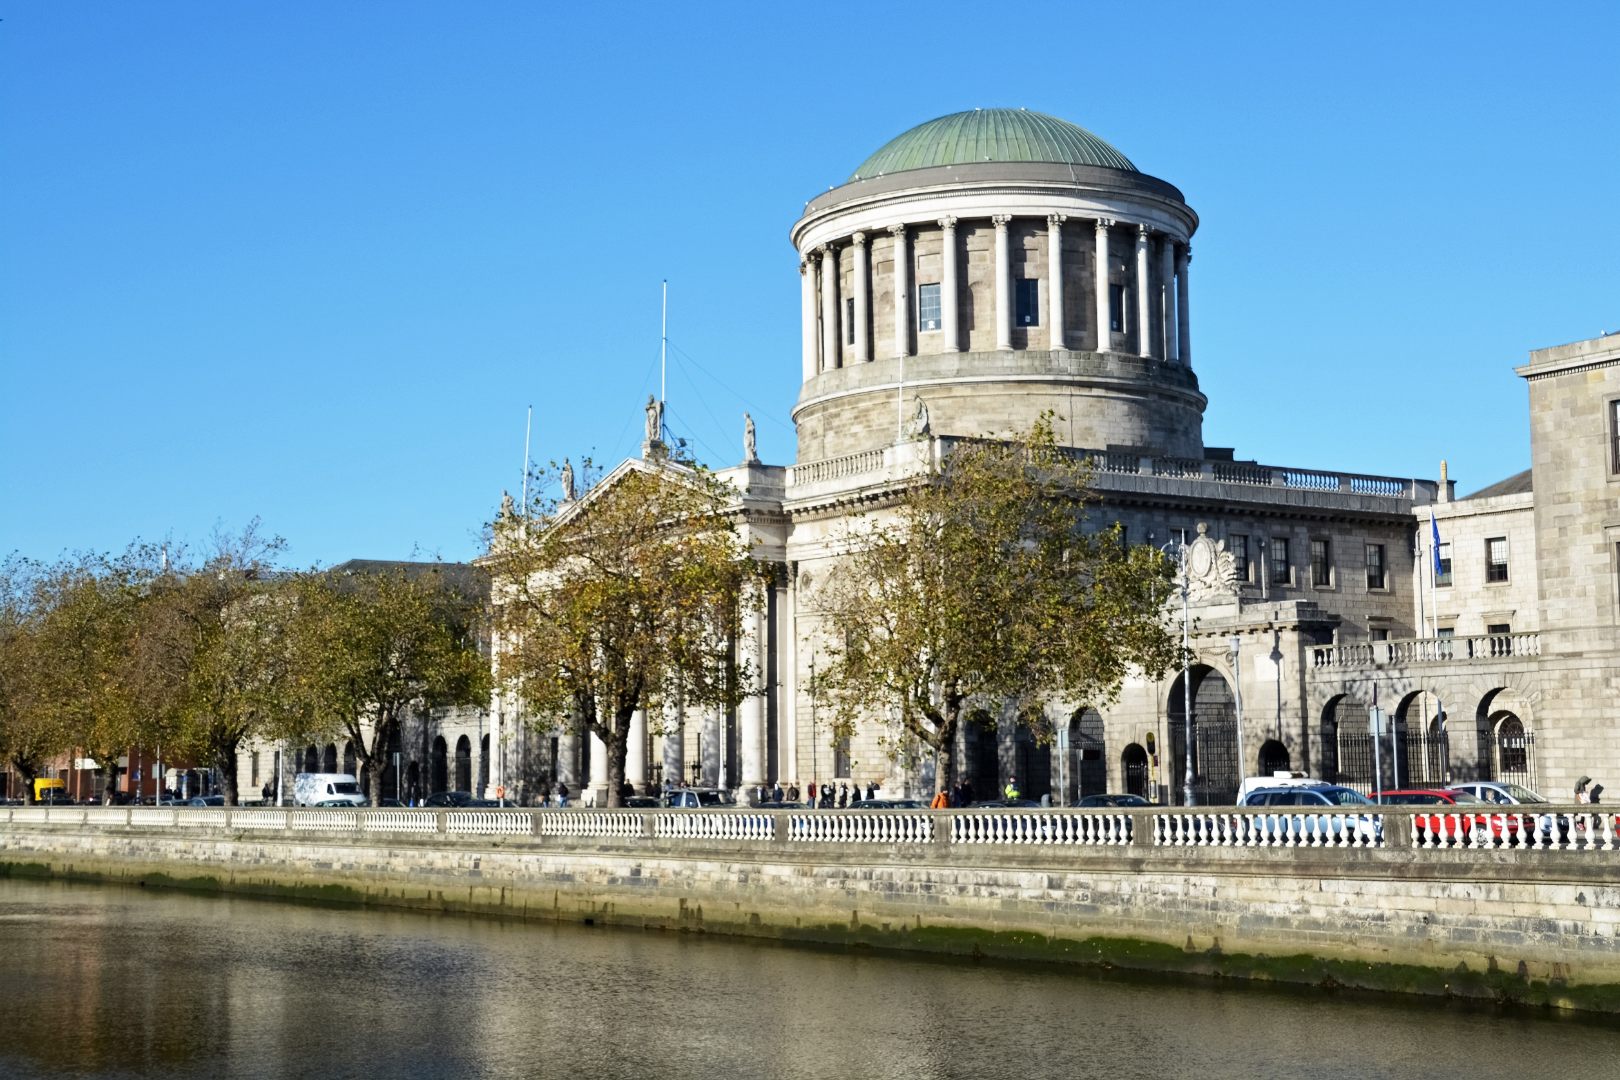

Gender Pay Gap Report
2025

Contents
1. Introduction 3
2. The Gender Pay Information Act, 2021 4
3. Courts Service 2024 5
4. Courts Service 2023 6
5. Courts Service 2022 7
6. Data 8
7. Using Gender Pay Gap information. 12

Introduction

The Courts Service in its People and Organisation Strategy 2025 to 2027 sets out its desire to be a workplace where everyone can thrive; be a place where people want to invest their careers to realise personal and organisation goals.
All public bodies in Ireland have responsibility to promote equality, prevent discrimination and protect the human rights of their employees, customers, service users and everyone affected by their policies and plans.
Delivering on our commitment to be a place where everyone feels equal is demonstrated in part by reporting the gap in pay between male and female staff.
The Courts Service as a civil service agency has a range of policies to support equal opportunities and female participation in the workforce. These include shorter working year to facilitate school holidays, maternity leave, parental leave, flexi time and paternity leave and Menopause support. Policies were introduced in 2024 to support those experiencing Domestic Violence and parents leave was increased for fathers.
The gap in pay between genders is distinct from the concept of unequal pay. Unequal pay means an employee cannot be paid less compared to another employee of the opposite sex who is doing work of equal value.
For 2025 the Courts Service mean gender pay gap was 1.1% i.e. males earned 1.1% more than females but the median gender pay gap was -5% i.e. females earned 5% more than males. Females comprised 64% and males comprised 36%.
The reporting period is from 01 July 2024 to 30 June 2025 and includes all those who were paid in the period. The data used in the analysis is provided by the National Shared Service Office (NSSO). The NSSO calculated the gender pay gap statistics for the Courts Service staff using data from the payroll system and human resources employee information database.
Remuneration includes base salary, higher duties allowance, overtime, sick pay, maternity pay, on call- and call-in compensation, public holiday pay, video link allowance, private secretary allowance, County Registrars, tipstaff and service officer allowances.
The Courts Service is bound by civil service pay grades and therefore has no control over determining pay for employees.
It can be concluded there is no immediate concern for the gender gap in pay in the Courts Service.

The Gender Pay Information Act, 2021
The Gender Pay Gap Information Act was signed into Irish law in 2021 and in 2022 employers with more than 250 employees had to report their gender pay gap.
Under the Act, employers are required to publish information on their gender pay gap, specifically, gender-based differences in average and median hourly remuneration, average and median bonus payments and the percentage of employees paid a bonus or benefits in kind.
The Gender Pay Gap Information Act 2021 defines the hourly gender pay gap as the difference between the average hourly remuneration of male employees and female employees expressed as a percentage of the average hourly remuneration of male employees.
All organisations are obliged to publish a broader explanation, giving the underlying reasons for any gap, and the measures the organisation intends to take to address it.
All of this should be publicly available, published either on the organisation’s website or made available on a central portal which the government intend to ultimately provide.

Courts Service 2025
The average or mean hourly gender pay gap was 1.1% in favour of males as shown in the table below:
When the data is ordered from least to greatest, females earned €1.20 per hour more than males. Thus, the median hourly gender pay gap was -5% as shown in the table below:
Salaries and hours worked reflect the cumulative remuneration and include overtime for the previous 12 months. No bonuses or benefit in kind were paid to Courts Service staff in this reporting period.
The table below sets out the percentage of females and males.

The table below sets out the mean gender pay gap per pay band with the associated grade.
- Courts Service 2022 to 2024
Below is a summary of for all gender pay gap reports.
2024
The mean hourly gender pay gap was -0.05% (rounded to -0.1% above) and females earned on average €0.01 more per hour than male colleagues.
The median hourly gender pay gap was -8.10% and females earned €1.81 more than their male colleagues.

2023
The mean hourly gender pay gap was -2.4%. Females earned on average €0.65 more per hour than their male colleagues.
The median hourly gender pay gap was -12.2%. Females earned €2.50 per hour more than males.
2022
The average hourly gender pay gap was -2.54%. Females earned on average €0.65 more per hour than their male colleagues.
The median hourly gender pay gap was -13.20%. females earned €2.59 per hour more than males.
In conclusion we can see the gender pay gap is reducing as male earnings catch up with female earnings.

Using Gender Pay Gap information.
The Courts Service established an Inclusion Group under the governance of our People & Organisation Strategy. All public bodies in Ireland have responsibility to promote equality, prevent discrimination and protect the human rights of employees, customers, service users and everyone affected by their policies and plans.
The Courts Service has developed a Public Sector Duty Action Plan to deliver on our obligations to be equitable and fair, attract and develop a diverse workforce.
The benefit of gender pay gap reporting is to provide data for us to evaluate and challenge ourselves around Equality, Diversity and Inclusion in our workplace and consider ways to enhance our support to all genders.

